Warmup-03

Adv. Web Application DEVELOPMENT

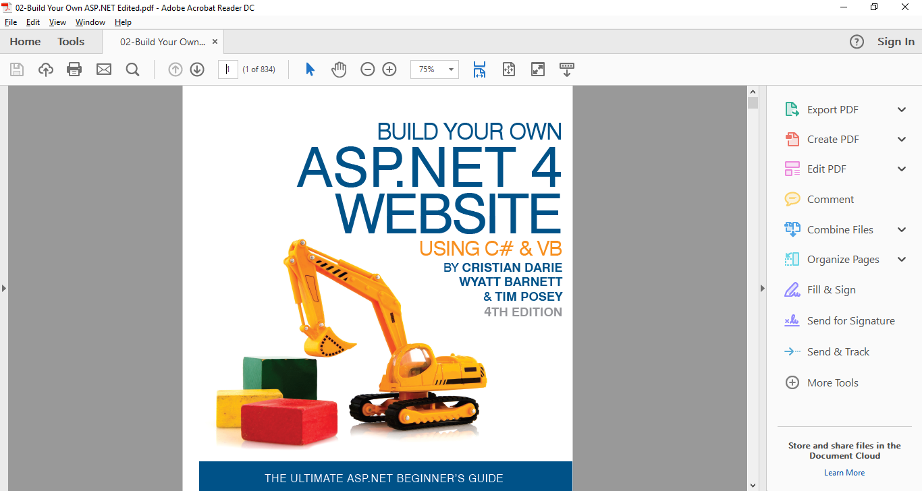

Contents



Tasks and Questions 1

Master Page 2

Menu control 3

CSS 4

Results 5

How I tested my application. 7

References 8

# Tasks and Questions

*“The time has come to turn your heart into a temple of fire. Your essence is gold hidden in dust. To reveal its splendor you need to burn in the fire of love.” ~Rumi*

## Task:

1. Please create an ASP.NET project to provide a simple ASP.NET webpage that contains the following components and items:

1. Using Master Page to have a unique template for all the pages
2. Use menu control to help you navigate when you are in different webpages
3. Using CSS concept to make a unified appearance You should make your own CSS file by editing and changing the current samples that you can easily find on Internet. Please cut the fluff (extra lines of CSS file) and just have those lines that you are going to use. You can use Marvio’s sample as your model.

# Master Page

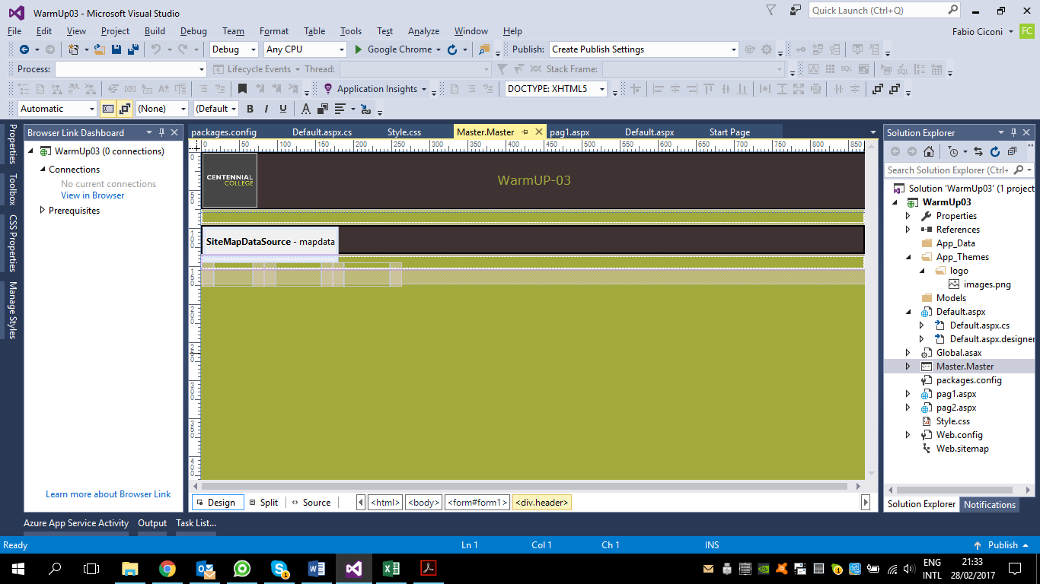

# Menu control

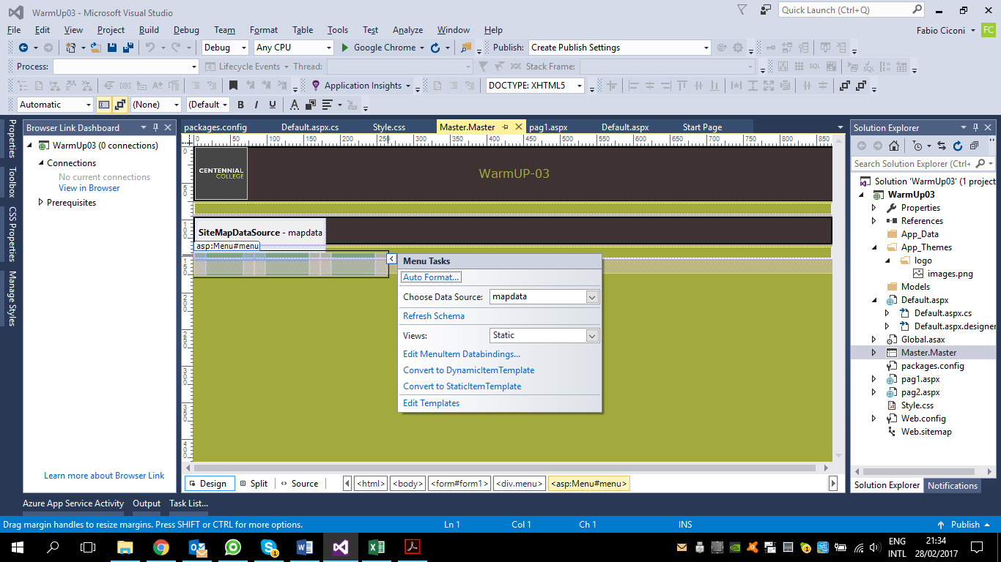

# CSS

body {

margin: 0;

padding: 0;

height: 100%;

width: 100%;

font-family: Verdana;

text-align: center;

color: red;

background-color: #a3aa3d;

}

#kk {

width: 70px;

height: 70px;

top: 2px;

left: 3px;

position: absolute;

border-radius: 6px;

}

form {

width: 100%;

height: 100%;

}

.header {

width: 100%;

height: 72px;

line-height: 70px;

background-color: #3e3332;

color: #a3aa3d;

border: 2px solid black;

border-radius: 12px;

}

.menu {

background: #3E3332;

height: 34px;

line-height: 30px;

border: 2px solid black;

margin-top: 2px !important;

margin-bottom: 2px !important;

border-radius: 64px !important;

}

.menu a {

color: #a3aa3d;

margin: 0 15px;

border: 0px solid;

border-radius: 12px;

cursor: pointer;

}

.menu a:hover {

background: #464647;

color: #efefef;

border: 2px solid #FFD700;

border-radius: 12px;

cursor: pointer;

}

# Results

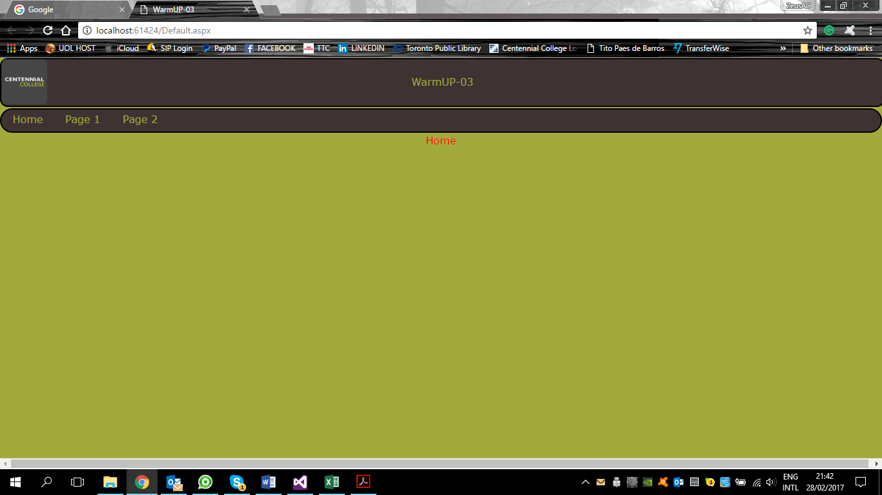

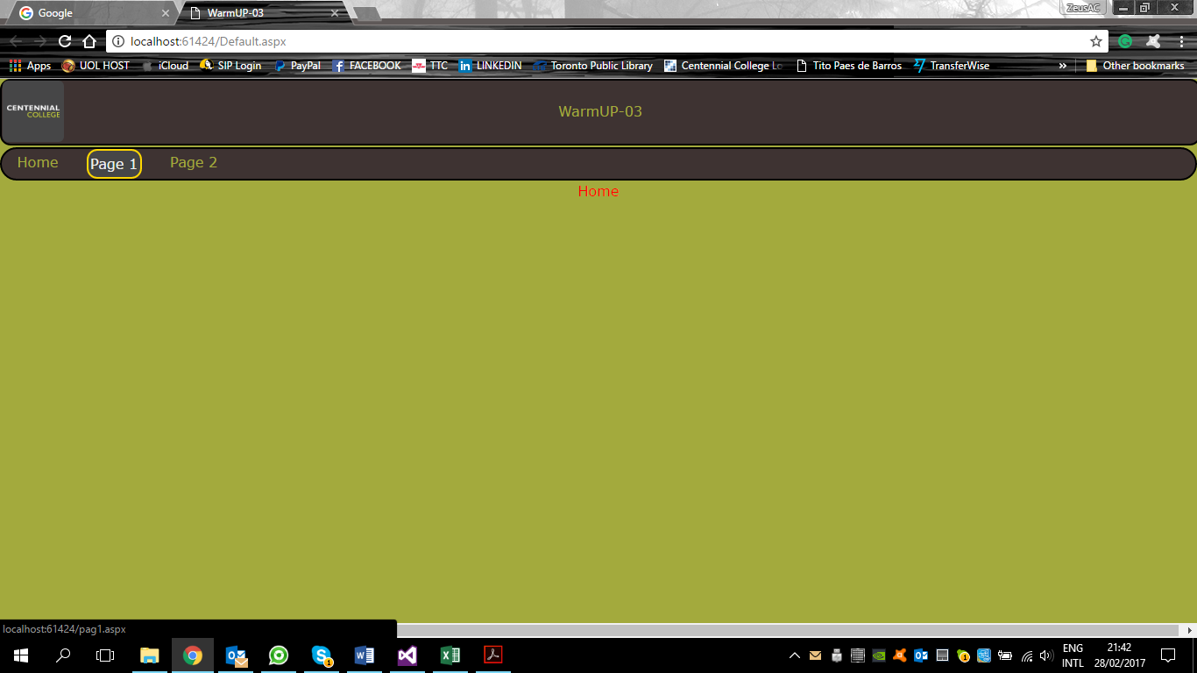

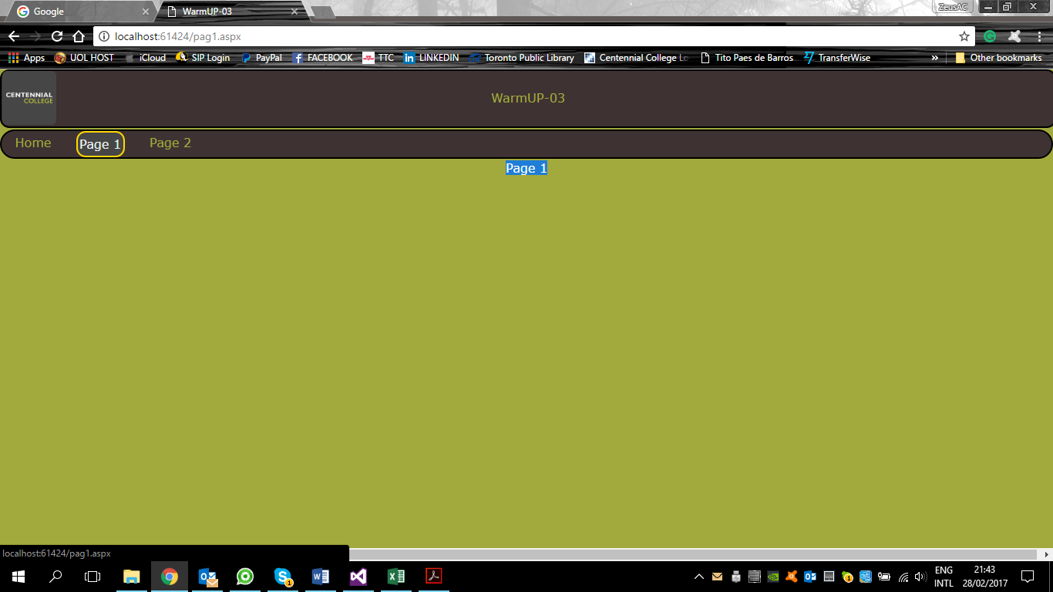

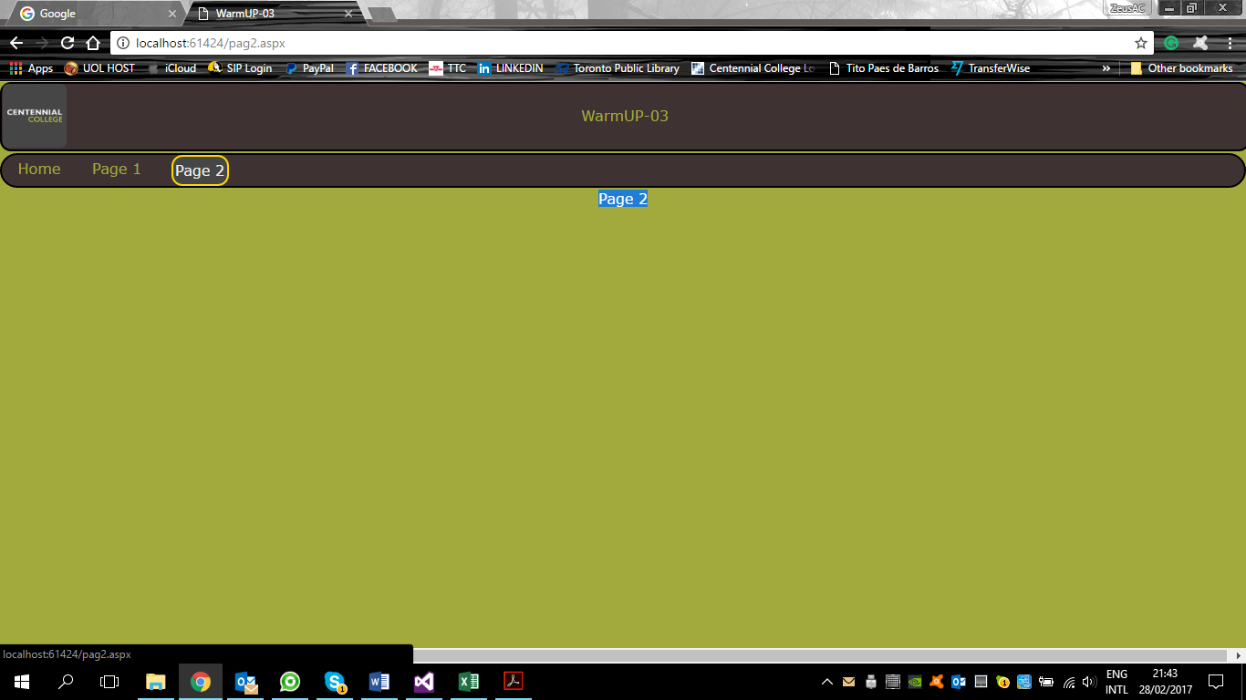

# How I tested my application.

I used the develop option in the Chrome browse that Marvio show to me.

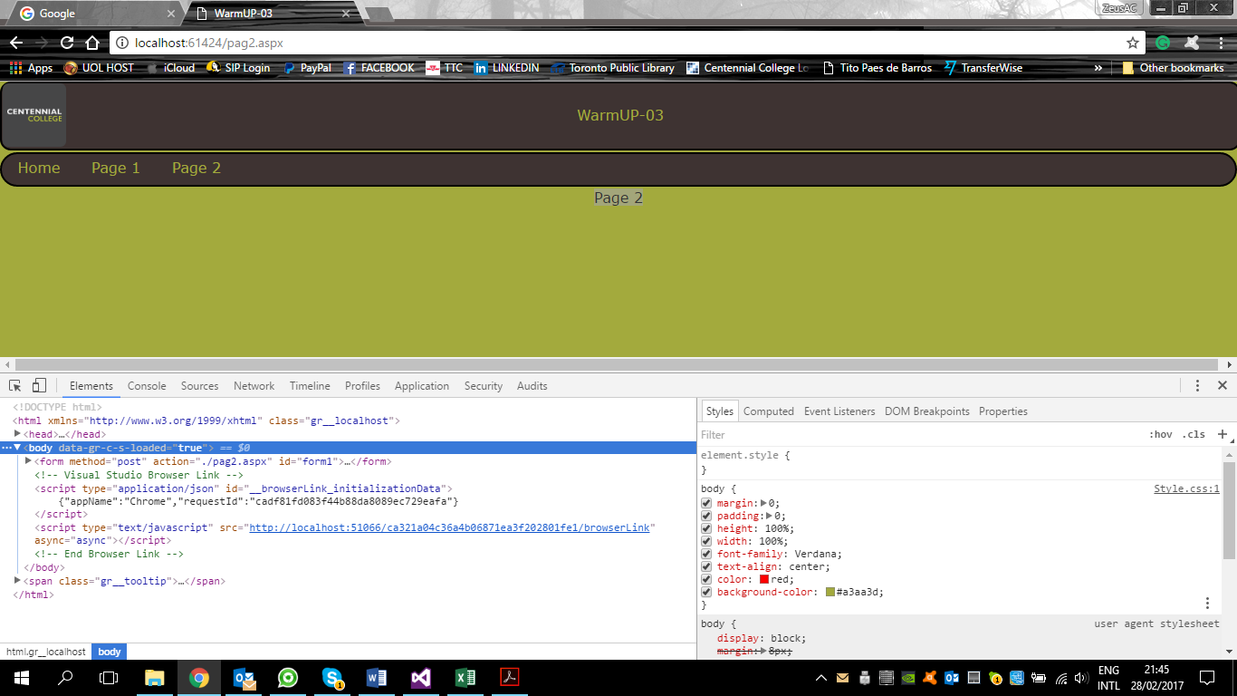

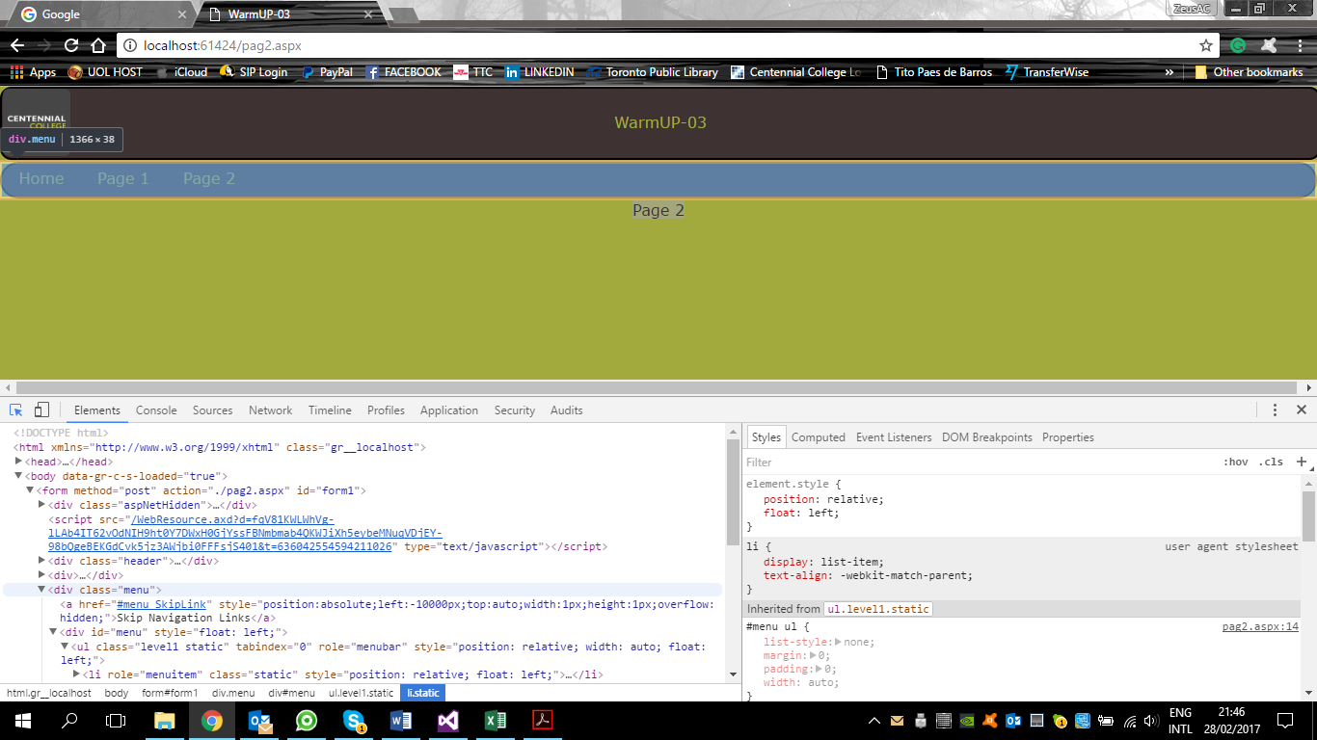

# References

Barnett, W., Posey, T., & Darie, C. (2011). *Build Your Own ASP.NET 4 Website Using C# & VB* (4th ed.). SitePoint.

*https://www.w3schools.com/*. (2017). Retrieved from W3Schools: https://www.w3schools.com/

Mario's Presentation